Final Project:

Analysis of Twitter Sentiment of Presidential Front Runners Donald Trump and Hillary Clinton

Bo Peng

For this project, I pulled 1000 live tweets with the keyword “Hillary Clinton”, and then another 1000 live tweets for “Donald Trump”. I then downloaded two text files which I labeled “positive words” and “negative words”. These two documents contained over 2000 words each, of negative and positive words in the English language. For example, for the word “amaze”, it also included “amazing” and “amazed”.

I then tried to match the words in the “positives words” and “negative words” document to the 1000 tweets for Donald Trump, and the 1000 tweets for Hillary Clinton. If there was a match of any of the positive or negative words in the tweet, it would give a +1 score for every positive word matched, and a -1 score for every negative word matched. So if there were 3 positive matching words and 2 negative matching words in one particular tweet, the total score would be +1. If there were no positive nor negative word matches, the score would be 0. I then found the mean sentiment score of both Hillary Clinton and Donald Trump. The mean sentiment score for Hillary Clinton was -0.306, and for Donald Trump the score was -0.297. This was done in python.

So it looks like one strong conclusive finding is that there is generally a more negative sentiment on twitter for both Donald Trump and Hillary Clinton than a positive sentiment. In other words, more negative things are tweeted out about these two candidates than positive. My data shows there is a slightly more negative sentiment for Hillary Clinton than Donald Trump, though more analysis would need to be done to prove that.

After that, I loaded the data into R and did some further analysis. I found the top 20 highest frequency words for both Donald Trump and Hillary Clinton tweets. Common filler words such as ‘i’, ‘he’, ‘she’ were removed. The top five highest occurring words for Hillary Clinton’s tweets were -govhowarddean, bernie, call, campaign and clintons. The top five highest occurring words for Donald Trump were ban, bernie, bush, business and call.

I then graphed a decision tree of both Donald Trump and Hillary Clinton in what R thought, using a CART model, which words would produce a negative sentiment, and which words would produce a positive sentiment. It did not produce any strong meaningful results, although it was interesting to look at. An interesting thing would have been, for example, if the word “emails” showed a link to negative sentiment prediction for a tweet from Hillary Clinton. There has been some press about her regarding emails that has been overall controversial.

Graphs and images of things mentioned above are shown on the next page.
Below is output of Clinton Dataframe and the mean sentiment score of both Clinton and Trump.
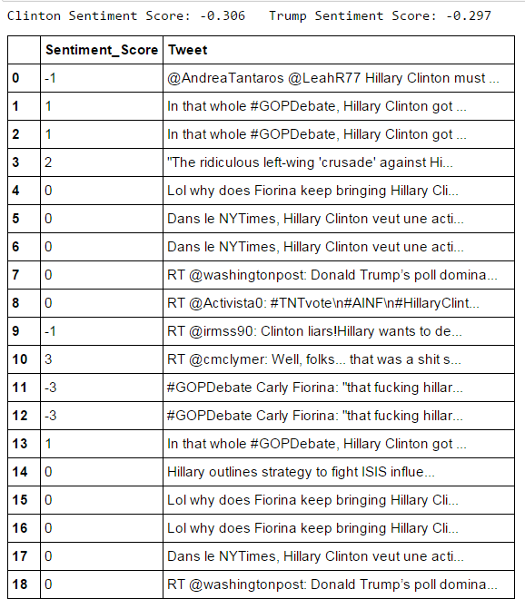

Below are the words from the Trump and Clinton data that had a word frequencies of 40 times or more.
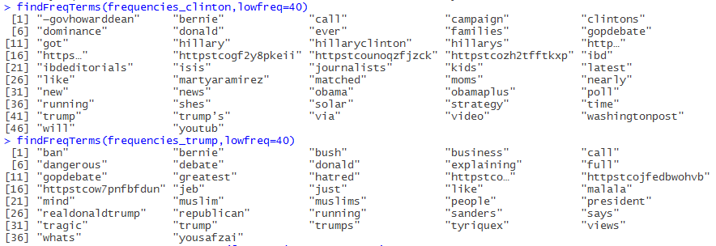

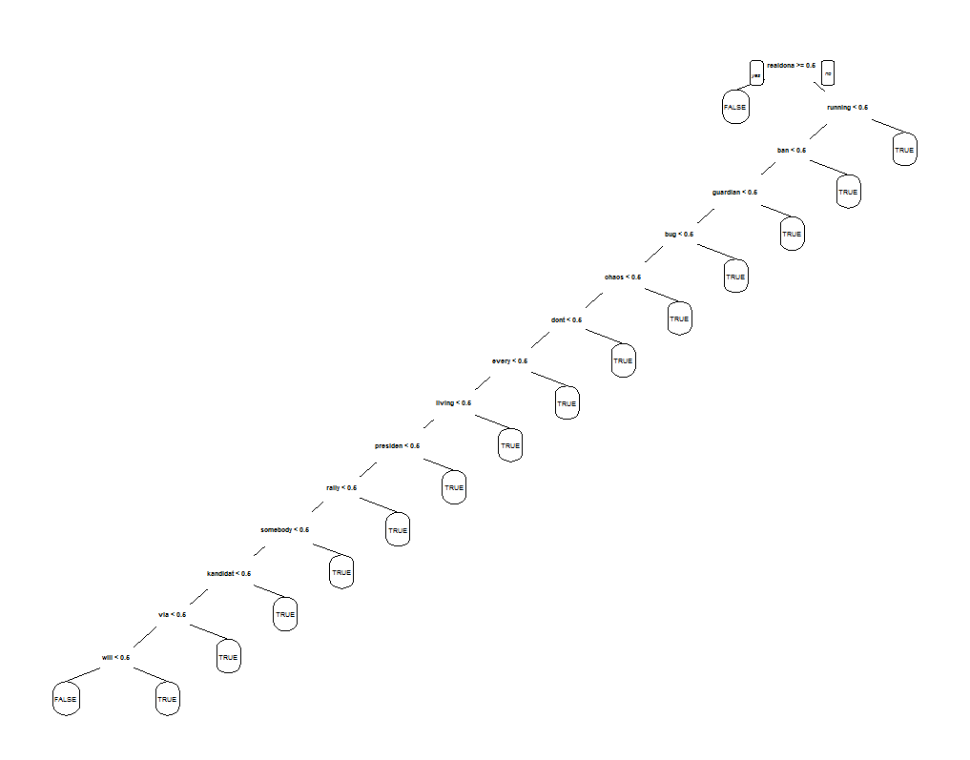
The two pictures above and below are the two CART decision trees that R produced using rpart. One interesting thing is for Donald Trump, when “realdona” was mentioned, it significantly decreased the tweets chances to have a negative sentiment. The word is stemmed, and should be “realdonaldtrump” which is Donald Trump’s twitter handle.
